**SCREENSHOTS FOR WIREFRAME OF WEBSITE :**

LANDING PAGE :



ABOUT US PAGE :

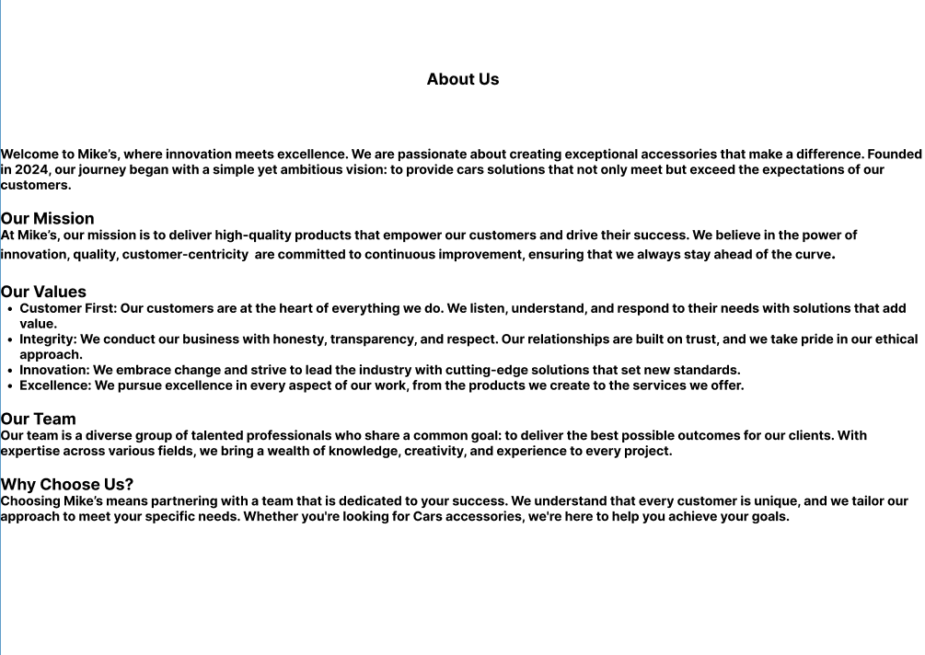

PRODUCTS ON LOANS PAGE :

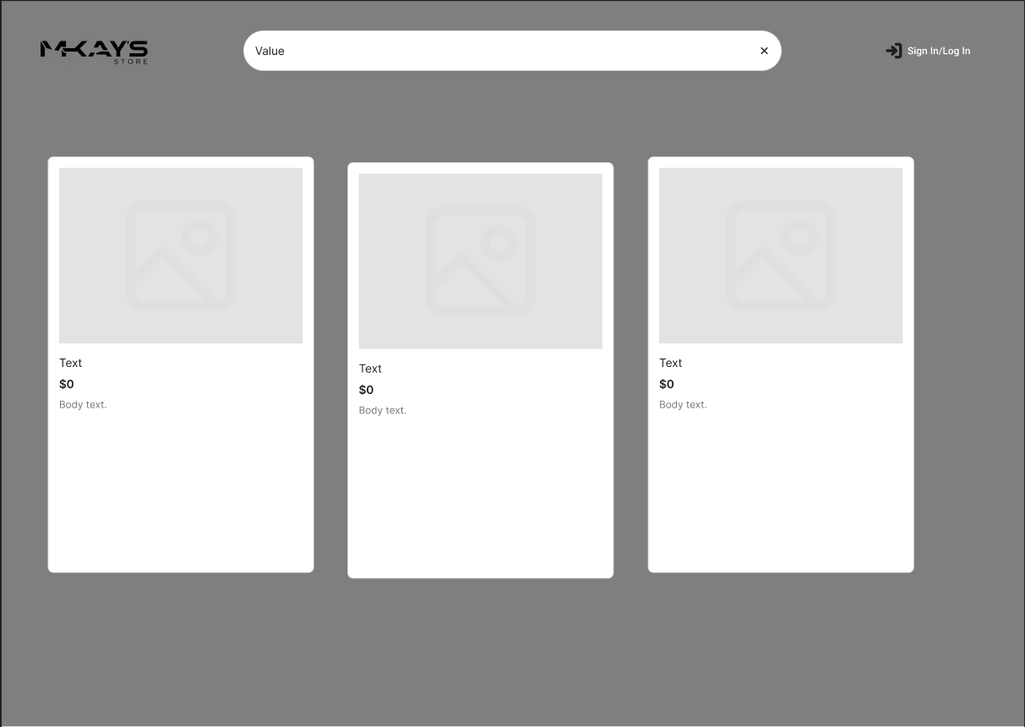

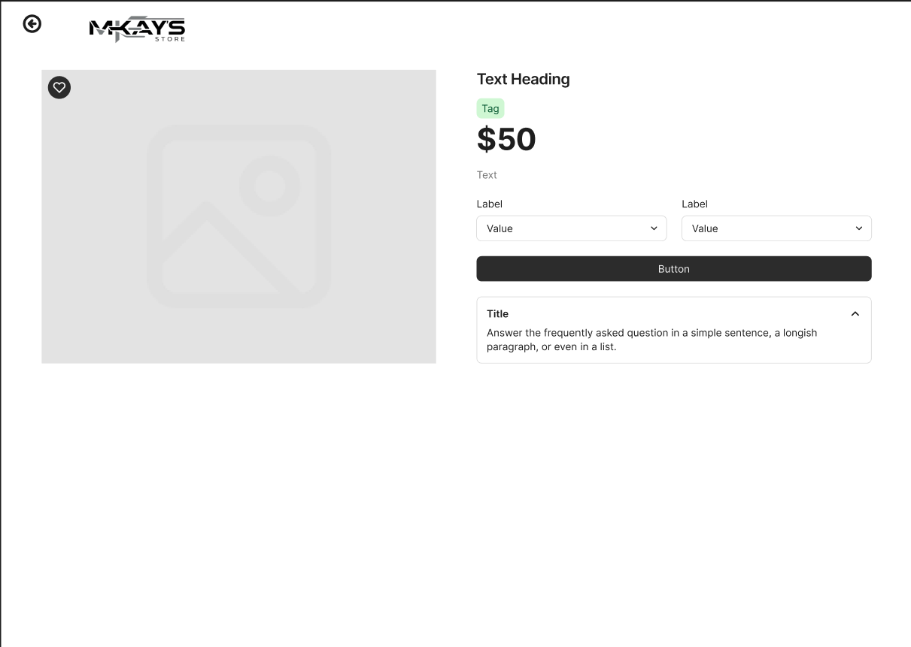

RESOURCES PAGE :

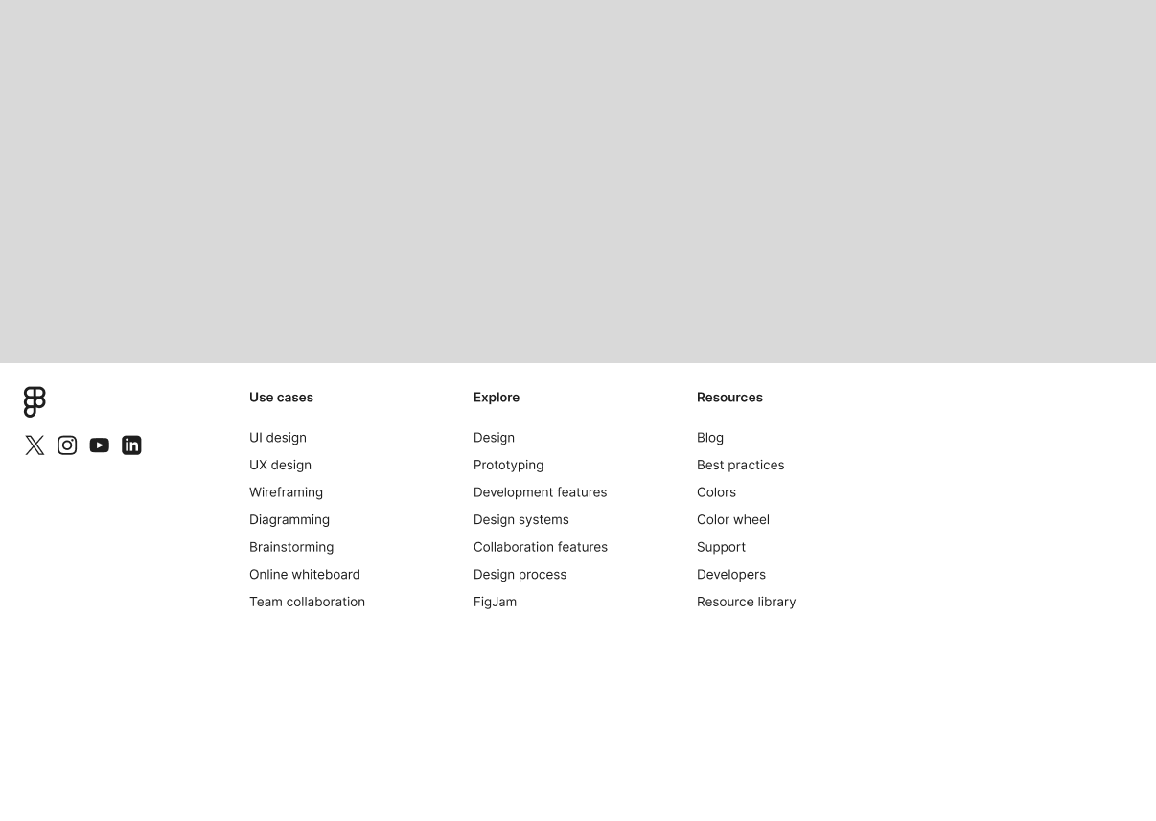

CONTACT US PAGE :

